Turning on the Heat with Spins and Their Transport Across Interfaces in Heterostructures

Hari Srikanth
Distinguished University Professor
Department of Physics, University of South Florida, Tampa FL, USA

Spin–heat coupling is at the heart of spin-caloritronics, an emerging field that explores how temperature gradients can generate, manipulate, and detect spin currents in magnetic materials and heterostructures. Beyond its fundamental interest, this interplay between heat and spin offers new pathways for low-power information processing and waste-heat energy harvesting in a world increasingly dominated by data- and AI-driven technologies. Magnetic materials offer unique pathways for converting energy between thermal, magnetic, and electronic forms. I will begin with a brief introduction to magnetic hyperthermia, where heat generated by nanoparticles in alternating magnetic fields is used for biomedical therapies. This nanoscale heating arises from relaxation dynamics, magnetic anisotropy, and size distribution effects, and illustrates how magnetic systems dissipate energy under driven conditions.

The main part of the talk will focus on the broader and rapidly developing field of spin caloritronics, which explores how temperature gradients can generate and manipulate spin currents. These spin–heat coupling phenomena—including the spin Seebeck and anomalous Nernst effects—provide new routes for energy harvesting, waste-heat utilization, and low-power spin transport. I will discuss how quantum materials and engineered magnetic heterostructures, such as garnets, Heusler compounds, topological materials, and high entropy alloys, offer versatile platforms to study and control these effects.

By connecting nanoscale hyperthermia to macroscale spin–heat conversion, the talk will show how manipulating heat and spin—across length scales and across material platforms—opens exciting opportunities for sensing, energy conversion, and next-generation spin-based technologies.

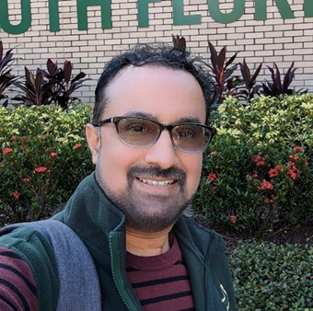
Hari Srikanth is a Distinguished University Professor at the University of South Florida. He received his Ph.D. in experimental condensed matter physics from the Indian Institute of Science, Bangalore and has been at USF since 2000 where he leads the Functional Materials Laboratory. He is also the Director of Florida Institute of Emergent Low-Dimensional Quantum Materials (FIELD-QM). Hari’s research spans a wide range of topics like quantum materials, magnetic materials and nanoscience. Hari has over 325 journal publications (with 13,200+ citations and an h-index of 66) and has given over 225 invited talks around the world. In 2019, he was an IEEE Magnetics Society Distinguished Lecturer. He is a Fellow of the American Physical Society, Fellow of the Institute of Physics and a Senior Member of IEEE. He currently serves as an Associate Editor for Physical Review B. Hari has been closely involved with the MMM and INTERMAG conferences for over 20 years serving as Publication Editor, Publication Chair and on program committees. His was the Special Events Chair for the MMM 2025 and also serves on the IEEE Magnetics Society AdCom. Hari is a recipient of an Alexander von Humboldt Research Award and a Fulbright Scholar Award and holds visiting professorships at University of Duisburg Essen in Germany, IIT Bombay and IISc Bangalore in India.

