Abstract – Spin+X Seminar – 30 January 2023

**Resonant dynamics and anomalous thermal diffusion of magnetic skyrmions**

Joo-Von Kim

*Centre for Nanoscience and Nanotechnology, CNRS, Université Paris-Saclay, 91120 Palaiseau, France*

Magnetic skyrmions are nanoscale, chiral topological solitons which exhibit a wide variety of interesting dynamical phenomena that have solicited much interest for fundamental reasons and technological applications alike. In this talk, I will discuss some recent experimental and theoretical results on two aspects of skyrmion dynamics in ferromagnetic thin film systems. The first involves the resonant dynamics in multilayered films of [Pt/FeCoB/AlOx]20, which are found to host dense robust skyrmion lattices at room temperature with a relatively low Gilbert damping of ∼0.02 [1]. Broadband ferromagnetic resonance measurements, combined with micromagnetic simulations, reveal distinct resonant modes detected in the skyrmion lattice phase. These are found to involve localised excitations, along with skyrmion core precession emitting spin waves into uniform background with wavelengths in the 50–80 nm range. The second aspect involves thermal diffusion of skyrmions in frustrated systems under spin-orbit torques, where the helicity dynamics leads to an anomalous drift that strongly depends on the strength of the Dzyaloshinskii-Moriya interaction. Such drift processes suggest the importance of helicity coupling to spin-orbit torques and may have bearing on dipole-stabilized bubbles for which drive-dependent skyrmion Hall angles and low drift velocities have been reported.

[1] T. Srivastava et al, arXiv:2111.11797 [cond-mat.mes-hall].

Short biography

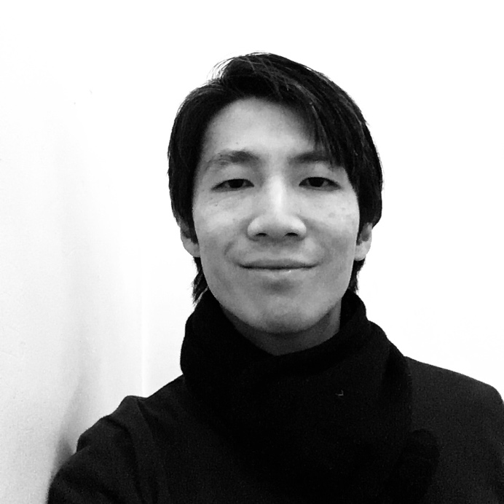

Joo-Von Kim is a theoretical and computational physicist at the Centre for Nanoscience and Nanotechnology (C2N), a research institute jointly operated by the French National Centre for Scientific Research (CNRS) and Université Paris-Saclay in Palaiseau, France. He has held a tenured position at the CNRS since 2004. His research interests lie in the nonlinear and stochastic magnetisation processes in nanoscale materials, with a particular focus on topological solitons and spin wave dynamics. He has co-authored two book chapters and over 120 research articles.