Single femto second laser to switch ferromagnetic layers mediated by spin transport

Stéphane Mangin

Institut Jean Lamour, UMR CNRS 7198, Université de Lorraine, Nancy, France

During the last decade all-optical ultrafast magnetization switching in magnetic material thin film without the assistance of an applied external magnetic field has been explored [1,2]. It has been shown that femto-second light pulses can induce magnetization reversal in a large variety of magnetic materials [3,4]. However, so far, only certain particular ferrimagnetic thin films exhibit magnetization switching via a single femto-second optical pulse. We will present the single-pulse switching of various magnetic material (ferrimagnetic, ferromagnetic) within a magnetic spin-valve structure and further show that the four possible magnetic configurations of the spin valve can be accessed using a sequence of single femto-second light pulses. Our experimental study reveals that the magnetization states are determined by spin-polarized currents generated by the light pulse interactions with the GdFeCo layer [5]. A detail study showing how spin-polarized currents are generated and how they interact with magnetic layers (Ferromagnetic or Ferrimagnetic) to lead to magnetization switching will be presented.

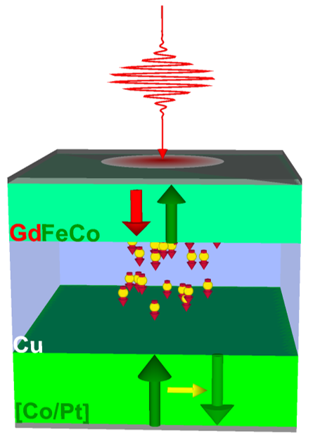 | Figure 1  Sketch of a spin-valve structure used to demonstrate femto-second single pulse switching of each magnetic layer independently. The generation of femto-second spin current is shown to play a major role.

[1] C. D. Stanciu, et al Phys. Rev. Lett. 2007, 99, 047601
[2] I. Radu et al, Nature 2011, 472, 207
[3] S. Mangin, et al, Nat. Mater. 2014, 13, 286
[4] C. -H. Lambert, et al Science 2014, 345, 1337
[5] S. Iihama et al Adv Matter 1804004 2018

*This document should consist of one page in A4 size.

